VeilPiercer Mesh
Defensive Detection and 5D Tracking Proof-of-Concept
Document Type | Defensive detection proof-of-concept white paper
Concept Thesis | Fuse passive plasma/interference sensing, 5D state mapping, and limited confirmation into a confidence-scored tracking mesh for low-signature targets.
Primary Use | Situational awareness, defensive monitoring, perimeter tracking, and anomaly detection
Status | Non-operational, defensive architecture draft
Abstract
VeilPiercer Mesh is a defensive, passive-first detection concept for monitoring low-signature or stealthy objects across shipboard, orbital, or perimeter environments. The architecture uses distributed mesh nodes to build a live environmental baseline, monitors plasma-background disturbance and interference anomalies for track seeds, and then forms a 5D state estimate that includes position, time, and orientation-aware viability. Only after passive confidence rises does the system permit low-energy secondary confirmation. The final product is not an autonomous firing solution; it is a confidence-scored awareness and tracking layer intended to improve detection, correlation, and defensive decision support.
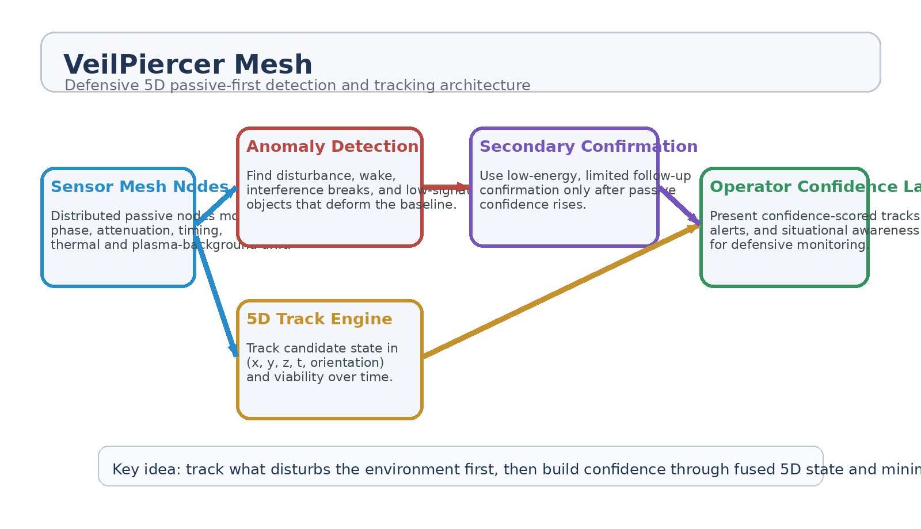
Figure 1. VeilPiercer Mesh architecture: passive mesh, anomaly detection, 5D track engine, limited confirmation, and operator confidence output.
1. Concept Thesis
The key insight is that low-signature objects do not need to reflect strongly to be noticed. They only need to disturb the environment in consistent ways. A distributed defensive mesh can watch for wake behavior, attenuation gaps, timing drift, phase disturbance, or plasma-background anomalies and then treat those changes as track seeds rather than waiting for one obvious reflection.
The architecture becomes stronger when the system stops asking a single sensor to be perfect. Instead, multiple viewpoints build a baseline, compare deviations, and estimate the moving state of a candidate through time.
2. Why 5D State Helps
In this concept, '5D' does not mean exotic fantasy targeting. It means the tracking model includes not just position, but time and orientation-aware viability. That lets the system reason about where a candidate is, how it is moving, which viewing angles remain useful, and how confidence should evolve from moment to moment.
• Three spatial dimensions capture location and motion geometry.
• Time captures continuity, persistence, and prediction quality.
• Orientation-aware viability captures how observation quality changes with aspect, attitude, or path through the field.
• The result is a tracking state richer than a simple dot on a map.
3. Layered Architecture
Layer | Subsystem | Primary Function | Output
L1 | Mesh Nodes | Distributed passive sensing across multiple positions and baselines. | Environmental baseline
L2 | Anomaly Engine | Detects interference breaks, plasma drift changes, and stealth-correlated disturbances. | Candidate track seeds
L3 | 5D Track Engine | Builds confidence-scored state across position, time, and orientation-aware viability. | Track continuity
L4 | Secondary Confirmation | Permits minimal low-energy confirmation only after passive confidence rises. | Refined confidence
L5 | Operator Layer | Presents tracks, alerts, and uncertainty to human decision-makers. | Defensive awareness

3.1 Passive-First Mesh Nodes
Each node monitors local conditions rather than shouting into the environment constantly. Useful channels can include passive plasma-background readings, interference pattern monitoring, thermal drift, timing irregularity, and other noninvasive signatures that reveal when the baseline is being bent. The value of the mesh comes from comparison between nodes, not from any one sensor claiming certainty.
3.2 Anomaly Detection
The anomaly engine looks for coherent disturbances that persist across multiple nodes or multiple time slices. A low-signature target may suppress reflection but still deform the field, leave a thermal or plasma wake, or produce a deficit where an expected interaction should have occurred. These deficits become the first hints of a track rather than being discarded as noise.
3.3 Secondary Confirmation
Confirmation should be limited and selective. The system remains defensive and passive-first by permitting only low-energy or low-visibility confirmation after passive confidence rises past threshold. That keeps the architecture from becoming a noisy active illuminator and preserves its value against stealth-like conditions.
4. Defensive Use Cases
• Shipboard or orbital perimeter awareness.
• Tracking low-signature craft or debris that disturb the local field but do not reflect strongly.
• Search and recovery of weak or intermittent targets in cluttered environments.
• Fusion of multiple passive channels into one operator-facing confidence layer.
• Monitoring blind zones where one sensor family alone is unreliable.
5. Confidence Model
A defensive tracking mesh should communicate uncertainty clearly. Tracks should be ranked by confidence, persistence, and supporting evidence instead of pretending every contact is equally real.
Confidence Tier | Meaning | Operator Action
Low | Single-node anomaly or short-lived disturbance. | Monitor; do not escalate.
Medium | Multi-node persistence with coherent 5D track seed. | Continue tracking; prepare confirmation.
High | Persistent multi-channel agreement with confirmation support. | Raise defensive alert and maintain watch.

6. Proof-of-Concept Build Path
Phase | Goal | Bench Activity | Success Signal
P1 | Baseline mesh | Build multiple passive nodes and record a stable environmental baseline across a controlled space. | Repeatable baseline map.
P2 | Anomaly seeding | Introduce weak disturbances and show that the mesh detects coherent changes better than a single sensor. | Reliable candidate seeds.
P3 | 5D tracking | Estimate motion and observation viability through time instead of plotting only static points. | Persistent track continuity.
P4 | Limited confirmation | Add a low-energy confirmation layer that only activates after passive confidence rises. | Improved confidence without constant emission.
P5 | Operator view | Present confidence tiers, alert states, and uncertainty to an operator-facing console. | Usable defensive awareness layer.

7. Measurements
• Detection rate for weak disturbances across single-node versus mesh configurations.
• Track persistence and continuity across time.
• False-alarm rate before and after multi-node fusion.
• Confidence improvement from limited confirmation.
• Localization uncertainty under clutter and low-signature conditions.
• Operator response quality when given tiered confidence instead of binary alerts.
8. Boundaries and Safety
This concept is deliberately defensive. It is a monitoring and tracking architecture, not a targeting or engagement recipe. The system is built to improve awareness, preserve passive advantage as long as possible, and help operators understand weak or stealthy contacts without collapsing immediately into active emission or automated action.
• No autonomous firing logic is part of this concept.
• Secondary confirmation remains low-energy and threshold-gated.
• Human operators remain responsible for escalation decisions.
• The value of the system lies in confidence-scored awareness, not aggressive action.
9. Conclusion
VeilPiercer Mesh turns 5D mapping into something operationally useful for defense: not mysticism, but a richer tracking state that fuses position, time, and observation viability into a passive-first awareness layer. By watching how a target disturbs the environment rather than waiting for ideal reflection, the mesh gives defenders a better chance of noticing low-signature objects early and tracking them with disciplined uncertainty.
The result is a coherent defensive detection architecture: build a baseline, watch for disturbance, form a 5D track, confirm only when needed, and present human operators with confidence instead of false certainty.
Working one-line doctrine: Track what disturbs the environment first, then build defensive confidence through fused 5D state and minimal confirmation.

